## Create Visio Artifact from Template (QRC)

## Introduction

This QRC shows how two ways an architect can quickly create a new Visio artifact from an EMAF template.

## Instructions to Create Artifact from within Visio

From Visio

1. Click the **File** Menu

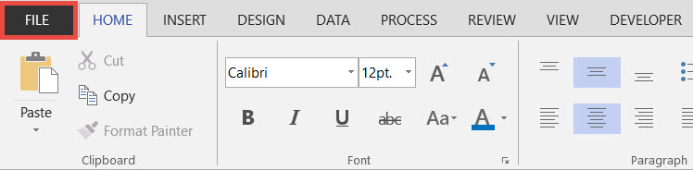

1. Click the **New** Sub-menu, then click the **CATEGORIES** link

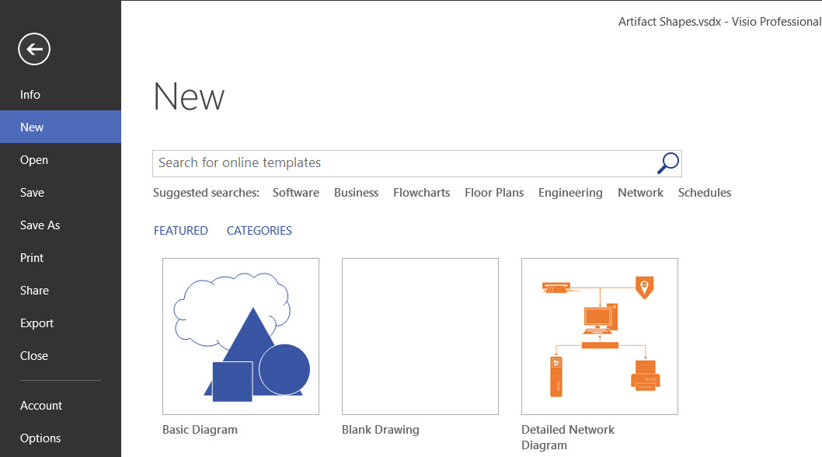

1. Icons of installed custom / 3rd Party templates are listed

Click on template to use

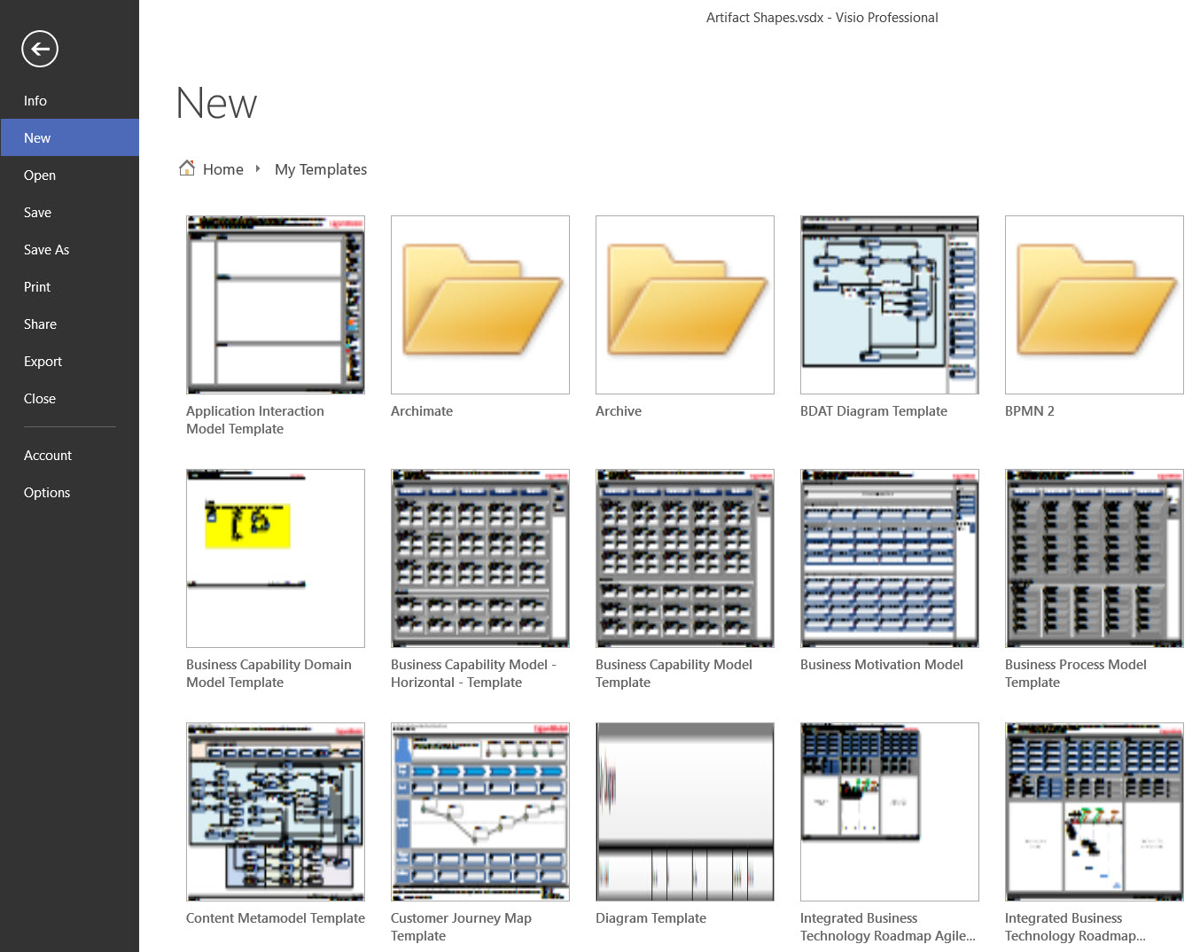

## Instructions to Create Artifact from within File Explorer

From File Explorer

1. Navigate to Template folder
   1. Via Quick Access

* Click to open the **Quick Access** branch
* Click to open the **My Templates** folder

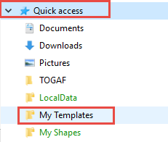

* 1. Via This PC
* Click to open the **Quick Access** branch
* Click to open the **Users** folder
* Click to open the folder associated to your network Id

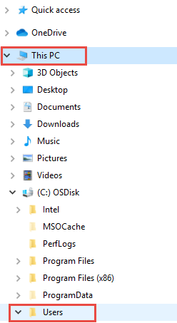

1. Create a new artifact
   * Scroll through the list of locally installed templates
   * Double-click the template to open a new artifact within Visio

